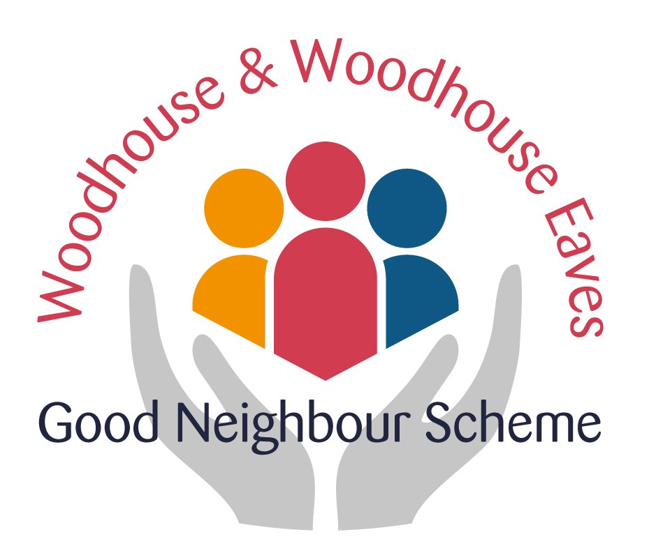
Befriending summary
October 2016 to September 2017

When Denise and I volunteered to take on the befriending co-ordination, we soon became aware just how much informal support is already available within the village and just how lucky we are to live in a place where neighbours generally look out for each other. We are also blessed with a variety of activities to suit all interests if it is possible to get out and about.
We have tried to link with other organisations where possible and to “fill the gaps” which other people or services are unable to cover. Referrals have come through a variety of sources - GP surgery, neighbours, church groups, relatives, Red Cross (after hospitalisation).
There is a core of very willing volunteers and I can safely say they all enjoy their visits just as much as we hope the recipients of the visits do. I know I have met some interesting people through taking on the rôle.
Visits are sometimes for a short while if someone is recovering from illness or incapacitated for whatever reason and some are more frequent and long term. Thanks to some very dedicated volunteers, weekly and multi-weekly visits are possible but I am conscious that this could be difficult to maintain for a variety of reasons and therefore the larger the pool of befrienders the easier it would be.
There have been a small number of people supported over the year -7 in all - but 75 visits have been made since October 2016, varying from ½ hour to 2 hours in length.
Where possible links have been made between like-minded recipients and offers made to introduce the befriendees to groups in the area. These could be accessed through the GNS transport if necessary.
Denise and I started the rôle 6 months ago and it seems as if the summer is a bit quieter as people are more able to get out and about but we anticipate that the winter may be a bit busier as the nights draw in and people succumb to winter ailments. So if you are considering joining the band of friends please let Denise or me know.

Cherrie Whatmuff
Befriending Co-ordinator

Cherrie and Denise can be contacted through the Telephone Co-ordinator on the Good Neighbour Scheme mobile 07561 890 100

